Trinity Valley Community College Associate Degree Program in Nursing
Conceptual Framework
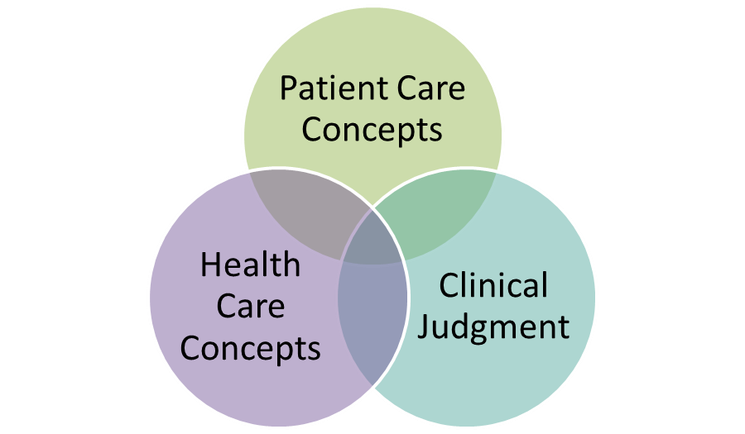
The conceptual framework of the TVCC ADN program is an outgrowth of its philosophy and reflects the faculty’s educational beliefs associated with nursing student development. The framework relies on components of the National League for Nursing (NLN) Educational Competencies Model. The curriculum is concept-based with integrating concepts within the framework drawn from the Quality and Safety Education for Nurses (QSEN) knowledge, skills and attitude (KSA) competencies for nursing graduates. The model utilizes the image of a tree, facilitating the fundamental appreciation toward foundational roots, core student involvement, and branching attributes that support necessary requirements and outcomes for licensure and professionalism. The framework provides guidance to curriculum development, management, outcomes identification and evaluation and focuses on the developmental needs of students while responding to patient dynamics in multiple settings.
Core Values
The model for the TVCC ADN program grows from three foundational core values: caring, ethics and integrity. These elements are central to nurse education and development. Caring is associated with the patient and the promotion of their well-being. Caring relates to self, colleagues and the profession of nursing. Caring is a learned dynamic to be experienced by students in classroom, clinical, and simulation. Included within this dynamic are elements of compassion, empathy, concern and helping others. Ethics is the systematic, autonomous, critical inquiry of inner values that direct decisions regarding right and wrong as they relate to conduct. Ethics involves the promotion of good and the avoidance of harm while providing nursing care. From a foundational core value perspective, integrity provides a cornerstone element that serves not only the needs of patients but as important, the development of the student, especially as professional nurse. This value addresses respect for an individual’s moral being in a manner that is consistent and without conditions or limitations. This interpersonal growth of the student paves the way for them to assume responsibility for patient management and provide critical judgment associated with that care.
Concept-Based Curriculum
The curriculum emphasizes deep learning about the discipline’s most central concepts rather than content, which leads to the student’s ability to develop habits of thought and pattern recognition and clinical judgment. The body of nursing knowledge is divided into 43 concepts. These concepts include professional nursing concepts related to the profession and the health care system and health care concepts related to biophysiological and psychosociocultural aspects. Concepts are distributed across the curriculum. Introduction to concepts include a concept analysis consisting of attributes, antecedents, inter-related concepts, sub-concepts, consequences and nursing care. After deep learning about the concepts, the student applies what they have learned to key exemplars across the lifespan. Further application occurs in a variety of clinical settings where students care for patients with additional exemplars.
Integrating Concepts
The educational program is a learning-centered experience. The faculty facilitates this direction through incorporation of learning experiences based on established nursing competencies. Six (QSEN) KSAs serve as integrating concepts, which serve as support branches to the program’s goals. The six concepts include patient-centered care, quality improvement, safety, teamwork and collaboration, evidence-based practice and informatics. Patient centered care recognizes the source of control in the care delivery dynamic. Teamwork and collaboration address the interaction and effectiveness of individuals as they work together to address patient needs. Evidence based practice describes the direction required to incorporate current clinical and patient related resources and research. Quality improvement facilitates and supports the ongoing requirements to evaluate and improve healthcare delivery and systems. Safety emphasizes the importance of minimizing risk to patients during healthcare delivery. Informatics is associated with the utilization, management and incorporation of relevant data and support systems to document care delivery, minimize error and maximize decision making. Together these six concepts serve as support and guidance to curriculum development, clinical and simulation experience planning and foundation for career development over time. Each element supports at least one of the program goals.
Program Goals
The program goals address four areas: quality of life, clinical judgment, professional identity and spirit of inquiry. Quality of life is associated with the ability to promote growth and well-being of patients, self and collegial members of the healthcare team. Clinical judgment entails using clinical reasoning and nursing science as a basis for decision making in nursing practice. Faculty assist students to reflect on their decision making in the effort to develop clinical judgment. Students develop over time a strong sense of identity as a professional nurse. That identity serves them individually as it relates to the nurse - patient relationship but equally as important to that of the larger association with the profession of nursing. The spirit of inquiry is a goal that serves the student and the lifelong learner. Its development encourages inquiring about all elements of patient care.
Each of these goals is associated with one or more integrating concepts and the student’s development over time as they progress through the various levels within the program. Achieving the outcome of quality of life requires thorough preparation in patient-centered care. Clinical judgment comes as the student develops their knowledge and appreciation of both quality improvement and various aspects of patient safety. From early on in the program students are exposed to and develop skills in association with both teamwork and collaboration. Together these skills contribute to the student’s abilities and development of professional identity. The outcome of spirit of inquiry comes as the student develops their knowledge and appreciation of evidence-based practice, quality improvement, and informatics.
Successful graduates of the program will be positioned to demonstrate key competencies and roles as a professional nurse as designated by the Texas Board of Nursing in the Differentiated Essential Competencies. These roles include becoming members of the nursing profession, being providers of patient-centered care, serving as patient safety advocates and contributing as members of the health care team.
Definitions
Core Competencies
The discrete and measureable skills, essential for the practice of nursing, that are developed by faculty to meet program outcomes.

Caring
Caring is the value of nursing in which there is high concern for human dignity. It includes forming relationships with individuals and families in compassionate, nurturing, protective, empathetic, nonjudgmental, open-minded and altruistic ways.

Ethics
Ethics is the systematic, autonomous, critical inquiry of inner values that direct decisions regarding right and wrong as they relate to conduct. Ethics involves the promotion of good and the avoidance of harm to clients under nursing care.

Integrity
Integrity means respecting the dignity and moral wholeness of every person without conditions or limitation.

Learner Centered
Learner centered relates to an orientation to learning that incorporates and reflects the uniqueness of an individual’s background, preparation, values, and initiative.

Integrating Concepts
The defined quality and safety competencies related to knowledge, skills and attitudes necessary to achieve program outcomes

Patient Centered Care
Patient centered care recognizes the patient as the central source of control in providing compassionate and coordinated care based on respect for patient’s preferences, values, and needs.

Quality Improvement
Quality improvement utilizes data and ongoing monitoring of outcomes and processes to design and test changes to the health care system.

Safety
Safety minimizes risk of harm to patients and providers through both system effectiveness and individual performance.

Teamwork and Collaboration
Teamwork and collaboration relates to effective functioning within nursing and inter-professional teams, fostering open communication, mutual respect, and shared decision-making to achieve quality patient care.

Evidence-Based Practice
Evidence based practice incorporates the best current evidence, patient/family preference and values for delivery of optimal health care.

Informatics
Informatics incorporates the use of information and technology to communicate, manage knowledge, mitigate error and support decision-making.

Quality of Life
Patient quality of life involves promotion of their self-determination, integrity, and ongoing growth as human beings.

Nursing Judgment
Nursing judgment is the ability to make decisions in practice, supported by evidence that incorporates nursing science and based on reflection of patient needs and responses in the provision of safe, quality care and that promotes the health of patients within a family and community.

Professional Identity
Professional identity entails implementation of the nursing role in ways that reflect integrity, responsibility, and ethical practice.

Spirit of Inquiry
The practice of nursing that examines evidence, challenges the status quo, questions underlying assumptions, and offers new insights to improve the quality of care for patients, families and communities.

National League of Nursing (2010). Outcomes and competencies for graduates of practical/vocational, diploma, associate degree, baccalaureate, master’s, practice doctorate, and research doctorate programs in nursing. New York City, New York: National League for Nursing.
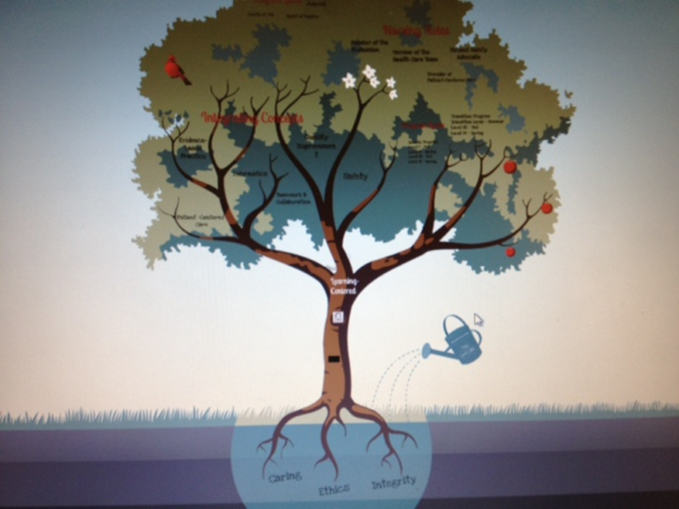
J:ADN\handbook\ADNConceptualFramework Reviewed 03/15

